Megan Cusey

Unit 1 Homework

Summer 2019

2.4 Suppose that a hospital tested the age and body fat data for 18 randomly selected adults with the following results:

|  |  |  |  |  |  |  |  |  |  |
| --- | --- | --- | --- | --- | --- | --- | --- | --- | --- |
| **age** | 23 | 23 | 27 | 27 | 39 | 41 | 47 | 49 | 50 |
| **%fat** | 9.5 | 26.5 | 7.8 | 17.8 | 31.4 | 25.9 | 27.4 | 27.2 | 31.2 |

|  |  |  |  |  |  |  |  |  |  |
| --- | --- | --- | --- | --- | --- | --- | --- | --- | --- |
| **age** | 52 | 54 | 54 | 56 | 57 | 58 | 58 | 60 | 61 |
| **%fat** | 34.6 | 42.5 | 28.8 | 33.4 | 30.2 | 34.1 | 32.9 | 41.2 | 35.7 |

1. Calculate the mean, median, and standard deviation of age and %fat.
   1. Mean:
      1. Age: 46.44
      2. %fat: 28.78
   2. Median
      1. Age: 51
      2. %fat: 30.7
   3. Standard Deviation:
      1. Age: 13.29
      2. %fat: 9.25
2. Draw the boxplot for age and %fat

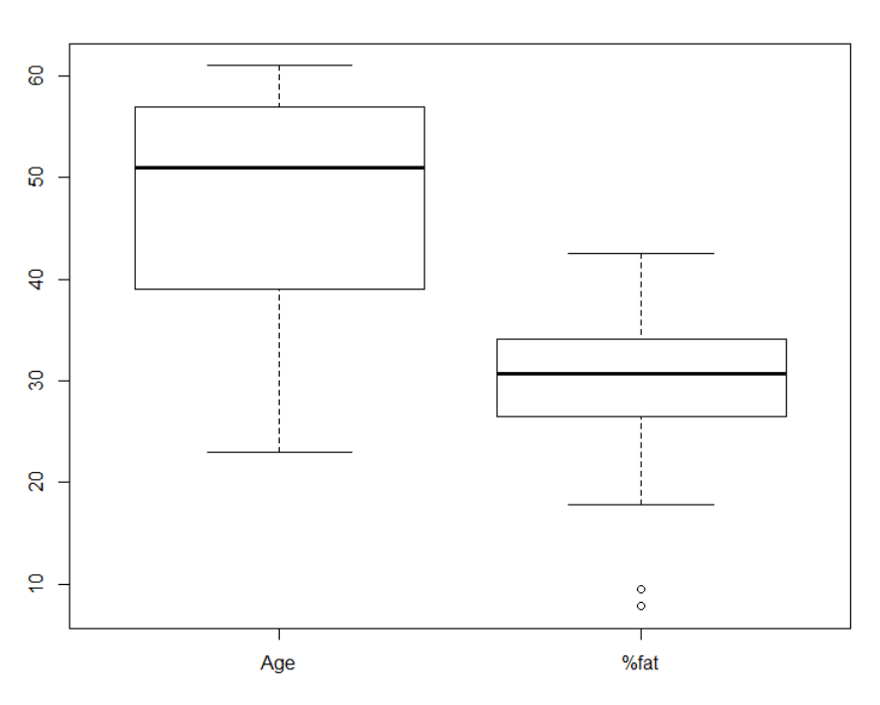

1. Draw a scatter plot and q-q plot based on these two variables.
   1. Scatter Plot:

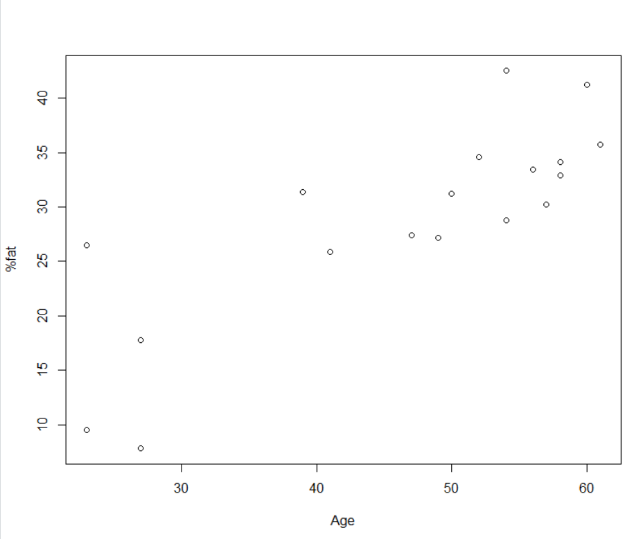

* 1. Q-Q Plot

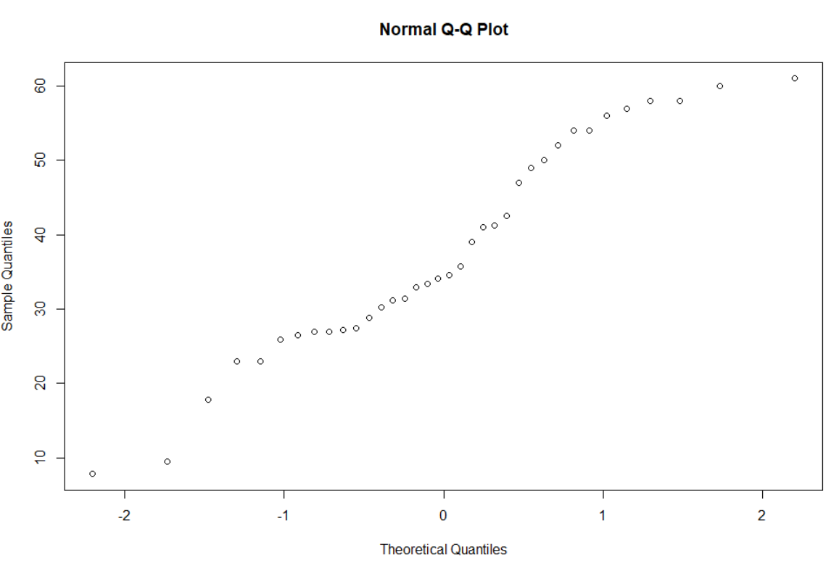

R Script:

library(pastecs)

## Load Data

exercise2.4 <- cbind(c(23,23,27,27,39,41,47,49,50,

52,54,54,56,57,58,58,60,61),

c(9.5,26.5,7.8,17.8,31.4,25.9,

27.4,27.2,31.2,34.6,42.5,28.8,

33.4,30.2,34.1,32.9,41.2,35.7))

colnames(exercise2.4) <- c("Age", "%fat")

## Get Mean, Median, Standard Deviation

stat.desc(exercise2)

## Draw Box Plot

boxplot(exercise2.4)

## Draw Scatter Plot

plot(exercise2.4)

## Draw q-q plot

qqnorm(exercise2.4)

2.6 Given two objects represented by tuples (22, 1, 42, 10) and (20, 0, 36, 8):

1. Compute the Euclidean distance between the two objects.
   1. 6.708204
2. Compute the Manhattan distance between the two objects.
   1. 11
3. Compute the Minkowski distance between the two objects, using q=3.
   1. 6.152449
4. Compute the supremum distance between the two objects.
   1. 6

R Script:

## Load Data

tuple1 <- c(22,1,42,10)

tuple2 <- c(20,0,36,8)

##Euclidean Distance

dist(rbind(tuple1,tuple2))

##Manhattan Distance

dist(rbind(tuple1,tuple2), method="manhattan")

##Minkowski Distance

dist(rbind(tuple1,tuple2), method="minkowski",p=3)

##Supremum Norm Distance

dist(rbind(tuple1,tuple2), method="maximum")